LITERA JOURNAL
AUTHOR GUIDELINES

- GENERAL INFORMATION
Articles are based on research on language, literature, and their teaching. Articles have not been previously published and are not being considered for publication by other journals. On the whole, the body of the article should be between 5,000 to a maximum of 8,000 words including the references. The article is written in Indonesian or English using Microsoft Word in 1.5 line spacing, 12pt Times New Roman font, and one column. The body of the article consists of several sections. The length proportions are ±20% for the introduction (including the title and abstract), a maximum of 10% for the research method, a minimum of 60% for the results and discussion, and ±10% for the conclusions and references.

- BODY OF THE ARTICLE

THE ARTICLE TITLE IS CONCISE AND REFLECTS THE CONTENT
(Centered, Bold, 12pt Times New Roman Font, Maximum of 13 Words)

Author’s name without title
Institution/Affiliation
E-mail address

Abstract
The abstract should reflect the whole content of the article and help the readers to find out its relevance to their interest and to decide whether they need to read the entire article. The abstract consists of the research background, focus, objectives, steps, and results and conclusions. The abstract is written in two languages (English and Indonesian) in one paragraph, in 1 line spacing, and between 150 to a maximum of 200 words.

Keywords
Keywords are important terms in the article, help the readers to find the article, and are written in bold and italics. List 3-5 keywords after the abstract.

INTRODUCTION
The introduction presents the research background, gaps between the ideal and actual conditions, support from current theories and studies relevant to the problem, and novelty in the form of innovation. This section is written in a maximum of 20% (including the title and abstract) of the body of the article.

METHOD
This section should be concisely but clearly and adequately written. It describes the research method operationally, including the procedure or steps, tools, materials, and instruments. If necessary, attach appendices for the instrument specification and part of the materials. Specific points, if any, can be described. This section is written in a maximum of 10% of the body of the article.

RESULTS AND DISCUSSION
To facilitate reading and understanding, the results are described first, followed by discussion. The subheadings of results and discussion are separated. This section should be the most, with a minimum of 60% of the body of the article.

Results
Results can be presented in tables of numbers, graphs, verbal descriptions, or a combination of the three. The tables, graphs, or pictures should not be too long, big, or many. The author should use a variety of presentations through tables, graphs, and verbal descriptions. The presented tables and graphs must be referred to in the text. The way to present a table is shown in Table 1. The table does not use vertical lines and horizontal lines are used only the upper and bottom parts. The font size in a table or picture can be smaller than that in the text.

Table 1 Proportions of the Body of the Article
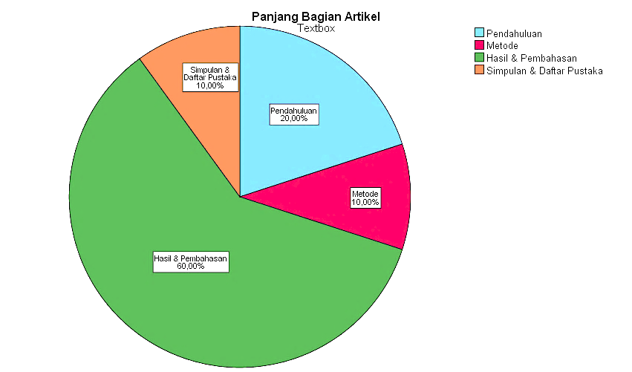
No. | Section | Proportion | Note
1. | Introduction (including the title and abstract) | 20% | Maximum
2. | Method | 10% | Maximum
3. | Results and Discussion | 60% | Minimum
4. | Conclusions and References | 10% | More or less

Figure 1 Proportions of the Body of the Article

The numbers in a table or graph should not be repeated in verbal descriptions presented before or after it.

Discussion
The discussion is intended to interpret the results in accordance with the theories applied and does not merely describe the results. It should be enriched by referring to the results of previous studies published in scientific journals. The discussion can be presented in sub-sections.

Sub-section 1 (bold and italics)
xxxxxxxxxx

Sub-section 2 (bold and italics)
yyyyyyyyyy

References in the body of the article use parentheses, i.e. (). A reference by one author is written (Widyastuti, 2018) and a reference by two authors (Nurgiyantoro & Efendi, 2017). For a reference by three to five authors, in the first citation all the names are included, e.g. (Zamzani, Rahayu, & Maslakhah, 2018), and in the subsequent citation only the first author’s name is written, followed by et al., e.g. (Zamzani et al., 2018). An author’s name in a reference can be written outside parentheses, e.g. Nurgiyantoro (2017), depending on the writing style. If the idea referred to is a direct quotation or fact on a particular page, the page should be included, e.g. (Nurgiyantoro & Efendi, 2017:144) or (Nurgiyantoro & Efendi, 2017:144-146) for the idea on several pages.
For referencing, authors are suggested that they should not use direct quotations or too many direct quotations. A direct quotation of less than 40 words is included in (not separated from) a paragraph with quotation marks (“...”). A direct quotation of 40 or more words is written in a block (separated from a paragraph), indented by half an inch from the margin, and without quotation marks followed by the author’s name, year, and page in parentheses (author’s name, year: page).
If a statement is the essence from several references, all the names of the authors of the sources are alphabetically written and a semicolon (;) is used to separate one from another, e.g. (Nurgiyantoro & Efendi, 2017; Triyono, 2017; Widyastuti, 2018; Zamzani et al., 2017). For a translated reference, the name referred to is the name of the author of the original version and the years of the translated and original versions are included (See the example in References).

CONCLUSIONS
Conclusions are not just data repetition but present the essence of interpretation. They can be statements regarding expectations as stated in the introduction, finally leading to results and discussion, so that there is compatibility. In addition, the prospect of the development of the research findings and the research application in the future (based on the results and discussion) can be included.

ACKNOWLEDGMENTS
In this section the author expresses his or her thanks to sponsors, funding agencies, resource persons, and other parties playing important roles in the study.

REFERENCES
References are alphabetically written. All the resources referred to in the article must be listed in the references and vice versa. The following are examples of how to write sources in references.

(Type: Book with the same author and publisher.)
American Psychological Association. 2010. Publication Manual of the American Psychological Association (6th edition). Washington, DC: American Psychological Association.

(Type: e-book)
Bransford, J. D., Brown, A. L., & Cocking, R. R. 2000. How People Learn: Brain, Mind, Experience and School. https://www.nap.edu/catalog/9853/how-people-learn-brain-mind-experience-and-school-expanded-edition.

(Type: Book with 1, 2, 3 or more authors)
Brown, H. D. 2007. Principles of Language Learning and Teaching (5th edition). New York: Addison Wesley Longman.

Leech, G.N. & Short, M.H. 2007. Style in Fiction: A Linguistic Introduction to English Fictional Prose. London: Longman.

(Type: Book section)
Hyland, K. 2011. Academic Discourse, in K. Hyland & B. Paltridge (eds). The Continuum Companion to Discourse Analysis. London: Continuum International Publishing Group. pp. 171-184.

(Type: Translated book)
Adler, M.J. & van Doren, C. 2012. How to Read a Book: Cara Jitu Mencapai Puncak Tujuan Membaca. (A. Santoso dan Ajeng AP, Penerjemah). Jakarta: Indonesia Publishing. (Versi Bahasa Inggris, 1972).

(Type: online journal article by 1, 2, and 3 authors)
Triyono, S. 2017. German Language Composites in Herman Hesse’s Novel Siddharta and Their Correspondences in the Indonesian Language. Litera, Jurnal Penelitian Bahasa, Sastra, dan Pengajarannya, 16(1), 170-179.
https://journal.uny.ac.id/index.php/litera/article/view/14259.

Nurgiyantoro, B. & Efendi, A. 2017. Re-Actualization of Puppet Characters in Modern Indonesian Fictions of the 21st Century. 3L: The Southeast Asian Journal of English Language Studies. 23 (2), 141-153. http://doi.org/10.17576/3L-2017-2302-11.

Zamzani, Rahayu, Y.E., & Maslakhah, S. 2017. Eksistensi Bahasa dalam Iklan Televisi Indonesia. Litera, Jurnal Penelitian Bahasa, Sastra, dan Pengajarannya. 16(2), 249-264. https://journal.uny.ac.id/index.php/litera/article/view/15971.

(Type: Proceedings)
Nurgiyantoro, B. 2017. Bahasa Sastra.Makalah disajikan pada Seminar Nasinal Linguistik (Semiotik): Linguistik dalam Berbagai Perspektif. In Nurhayati & I.M. Said (eds), Universitas Hasanudin, Makasar, Indonesia. Hal 1-8.

(Type: Institution’s publication)
Kemendikbud. 2016. Buku Saku Gerakan Literasi Sekolah. Jakarta: Direktorat Jenderal Pendidikan Dasar dan Menengah.

Appendices
(If available)

An author whose native language is not Indonesian may write the abstract in English only.

