Article title here in Sentence case (Align Left, Bold, Times New Roman 14, Maximum of 14 words)

First Writer ^{1*}, Second Writer ¹, & Third Writer ² (Full names without titles)
¹ Affiliation.
² Affiliation.
* Corresponding Author. Email: xxx

Abstract  The abstract firmly states the aim, method, and findings of the research. It is written narratively in a paragraph of maximum 200 words. It should clearly reflects the content of the manuscript, especially what this research aims, how the data were collected, analyzed, and/or interpreted, how the instruments were validated, and what the findings indicate. | Article History  Received:  -  Revised:  -  Accepted:  -  Available online:  -
Keywords: keyword 1; keyword 2; keyword 3; keyword 4; keyword 5
This is an open access article under the CC-BY-SA license.

INTRODUCTION
Introduction contains background, rationale, and/or the urgency of the research. Reference (literature or relevant research(es) need to be included in in this part; its relation to the justification of the research urgency; the emergence of research problems; alternative solution; and the solutions which are chosen. In writing the citation in the text, the following elements should be presented clearly: the last name of the author; year of publication; and the page in which the cited text is located. For example: From the year 1990, vocational school is only available from senior secondary school or starts from grade 10 (Paryono, 2005). We strongly recommend the authors to use Reference Manager application in writing the citation and references list.
Problems, aims/objectives, and benefits of the research, and operational definition (if needed), are written narratively in paragraphs. Please notice that all text/words written in non-English languages must be written in italic form seperti tulisan ini.
HEADING 1
The main body of the review article is organized in a certain way such as chronological or thematic evaluation of sources.
Sub-heading1
Text running.............................................
Sub-heading2
Text running................................................
Sub-heading3
Text running................................................
HEADING 2
Text running...............................................
If figures or tables need to be added, do not forget to write a figure number and caption below the figure, and a table number and title above the table. Each figure and table presented in the paper must be referred to the text. For example, the styles shown in Figure 1 are used for formatting the manuscript to be submitted (this is a sentence for referring a figure).

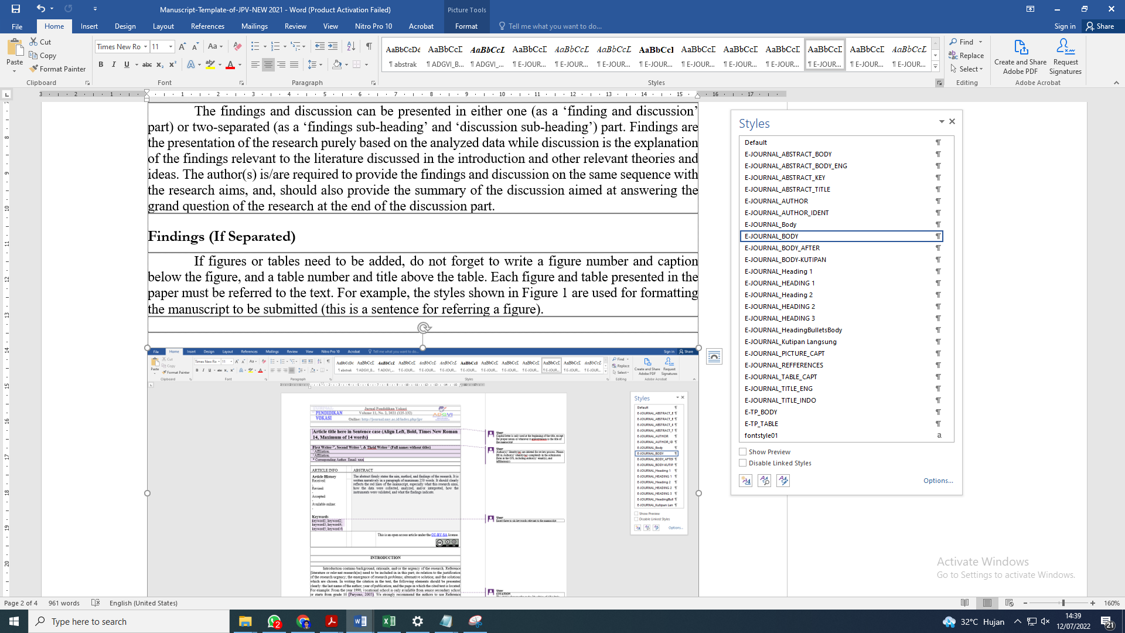
Figure 1. Bringing Up Style in the Journal Template

The writing format must comply with the style provided in this template. The Style is shown in the Microsoft Word in Home tab and then Change Style sub-tab as shown in Figure 1. Style is used by putting the pointer to the text, then clicking on the appropriate Style. Table 1 is the list of the Style content and its function. Comments which appear in this template can be deleted by putting the pointer to the highlighted text, then choose Review tab and choose Delete.
Table 1. Style and Its Function
No. | Style Name | Function
1 | E-JOURNAL_ABSTRACT BODY | Abstract
3 | E-JOURNAL_AUTHOR | Author(s)
4 | E-JOURNAL_AUTHOR_IDNET | Author(s) Identity(es)
5 | E-JOURNAL_BODY | Article text/paragraphs
6 | E-JOURNAL_PICTURE_CAPT | Figure caption
7 | E-JOURNAL_HEADING 1 | Chapter (Bold)
8 | E-JOURNAL_HEADING 2 | Sub-chapter (non-italic, non-bold)
9 | E-JOURNAL_HEADING 3 | Sub-chapter (italic)
10 | E-JOURNAL_BODY-KUTIPAN | Citation
11 | E-JOURNAL_REFERENCES | References writing
12 | E-JOURNAL_TABLE_CAPT | Table caption
13 | E-JOURNAL_TITLE | Article title

CONCLUSION
Conclusion should be derived from the depth and breadth of discussion section. It begins with a summary of the findings, the followed by a conclusive statement and implications on theory, practice, and policy of the related field.
ACKNOWLEDGMENT (if any)
The funding or grant-awarding bodies are acknowledged in this separate paragraph. For single agency grant: "This work was supported by the [Name of Funding Agency] under Grant [number xxxx].
REFERENCES
The citation and references are referred to American Psychological Association (APA) (7th Edition) style. Authors are strongly recommended to use a reference manager such as Mendeley.

